REST - Get country based on country code
Created a CountryService class inside the service package
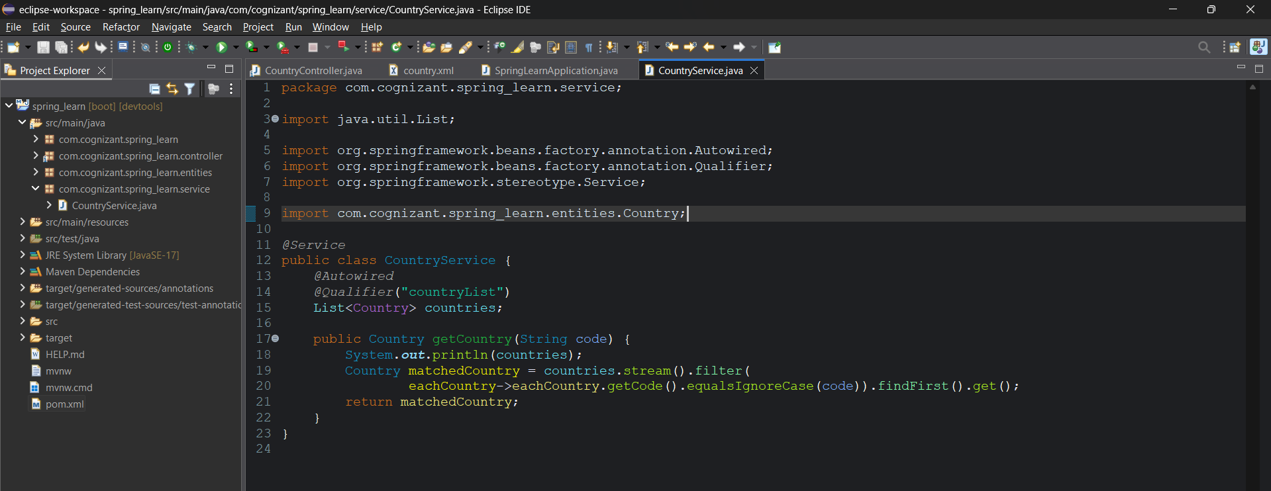
Use the CountryService class in the CountryController class.
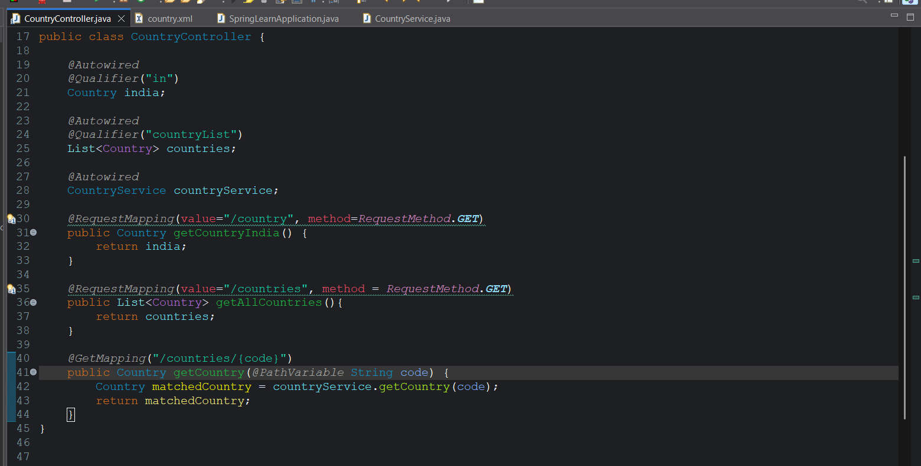
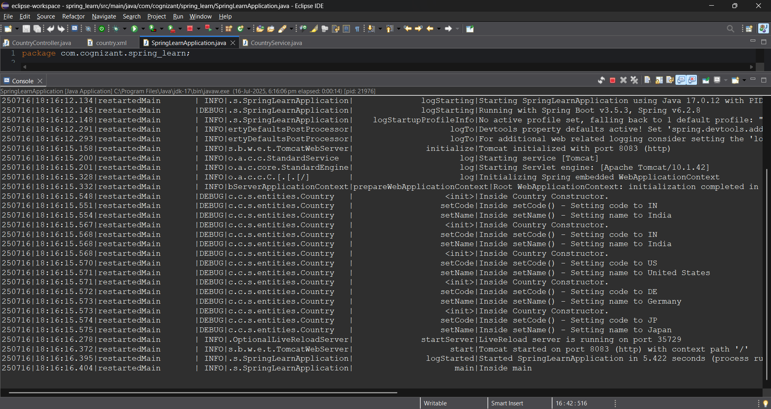
Postman:
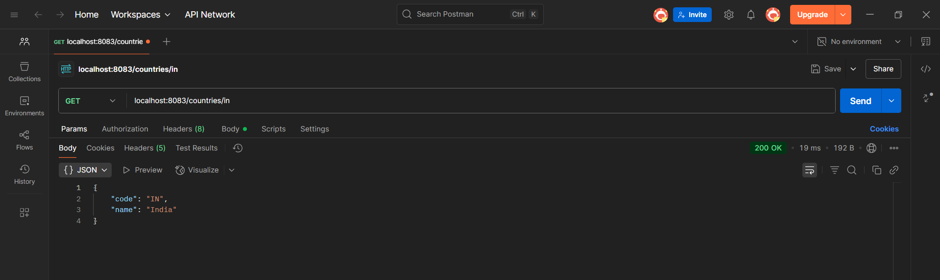
Browser:
